TALENT QUEST FOR INDIA - ULLAS SUMMIT PROGRAM
ACADEMIC YEAR: 2024 – 2025
Expenses Details
Zone: WEST 1
Team: K S RANGSAMY COLLEGE OF TECHNOLOGY
School Name: GOVT.HR.SEC.SCHOOL
No. of the Summit / Event: Art Education
No. of Session/Day: DAY 6
Grade: 9TH & 11TH GRADE
Date:05/02/2026
SPOC / Finance Officer Name: NARENDHAR D / KISHORE

S.NO | Description | No of Volunteers | Count x Amount (Rs) | Total Amount (Rs) | Bill /Ticket attached | Remarks (If any)
1. | K.S.R to Salem | 7 | 7*39 | 273 | 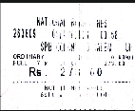
2. | Tcode to  Salem | 1 | 1X31 | 31 | 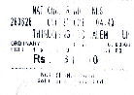
3. | Salem to  Harur | 4 | 4X65 | 260 | 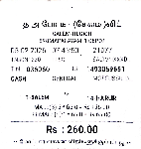
4. | Harur to  Andiyur | 2 | 2X25 | 50
5. | Harur to Bairnaikanpatti | 2 | 2X25 | 50 | 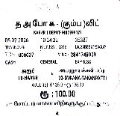  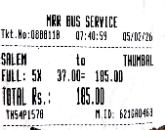
6. | Salem to Thumbal | 5 | 5X37 | 185
7. | Thumbal to Velanur | 2 | 2*10 | 20 | 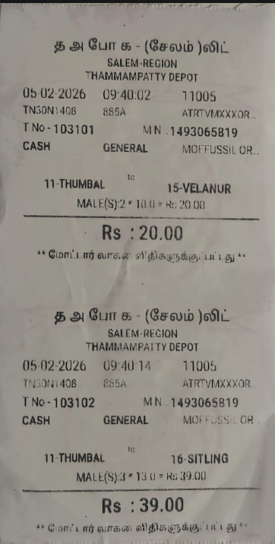
8. | Thumbal to Sittling | 3 | 3*13 | 39
9. | Sittling to Salem | 5 | 5*48 | 240 | 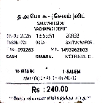
10. | Bairnaikanpati to Andiyur | 2 | 2*10 | 20 | 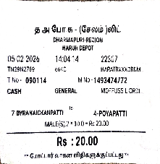
11. | Andiyur to Harur | 3 | 3*15 | 45 | 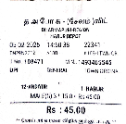
12. | Andiyur to Ammapettai | 1 | 1*8 | 8 | 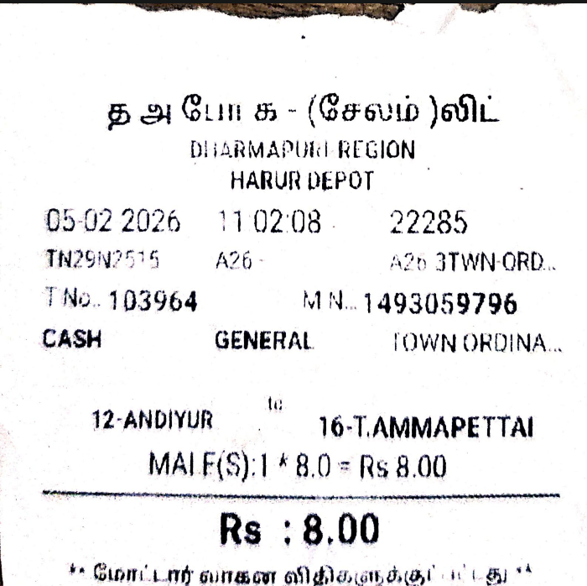
13. | Harur to Salem | 4 | 4*50 | 200 | 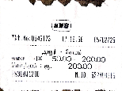
14. | Ammapettai to Andiyur | 1 | 1*7 | 7 | 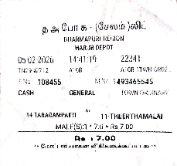
15. | Salem to Tcode | 3 | 3*31 | 93 | 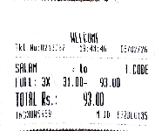
16. | Salem to Tcode | 4 | 4*31 | 124 | 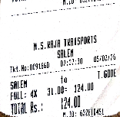
17. | Tcode to KSR | 4 | 4*10 | 40 | 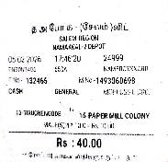
18. | Tcode to KSR | 3 | 3*10 | 30 | 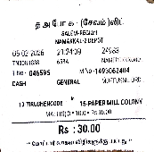
19. | Theevattipatti to salem | 1 | 1*19 | 19 | 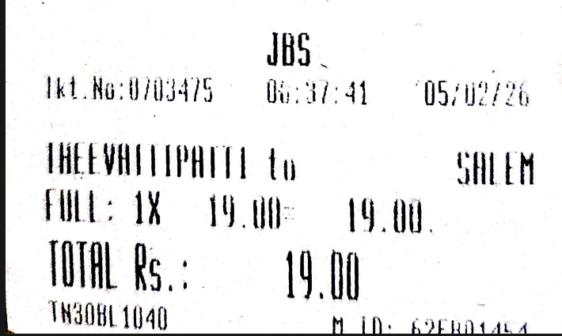
20. | Salem to Theevatiipatti | 1 | 1*19 | 19 | 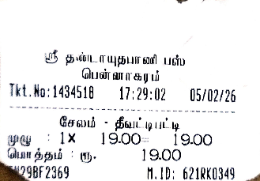
21. | Breakfast | 10 | - | 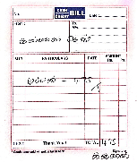  750 | 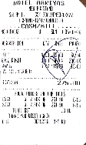
22. | Lunch | 10 | - | 790 | 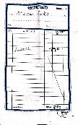
23. | Refreshment | 10 | - | 722 | 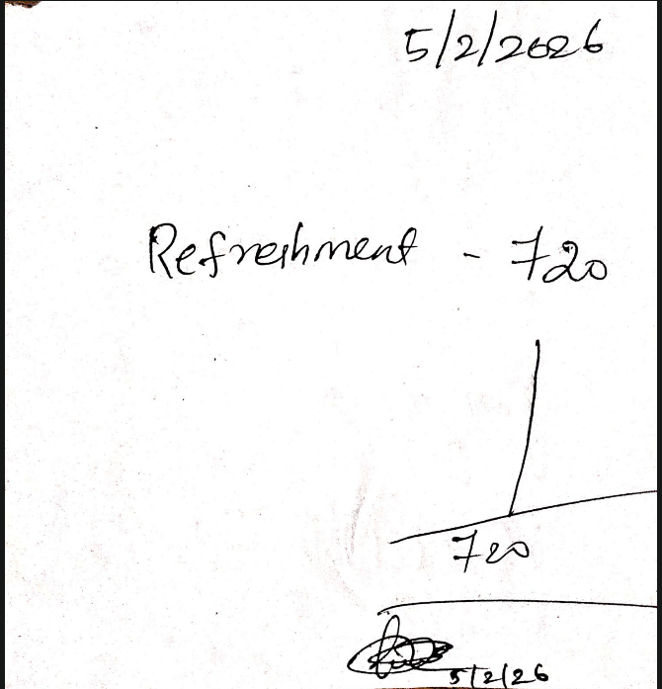
24. | Dinner | 10 | - | 990 | 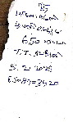  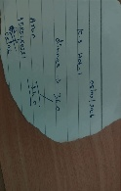
 | Total Travel Expenses | 1753
 | Total Food Expenses | 3252
 | Total | 5005

Name of Volunteers:
- Narendhar
- Jotheeswaran
- Kanishka
- Bala sankaran
- Deepak
- Gokulan
- Mathan
- Hariprasath
- Manisha
- Hari Prakash

